

RAW MATERIAL SAVINGS

The raw material costs associated with cable manufacture are continuously reaching unexpected peaks. Typically, a cable manufacturer today pays around EUR 5,500.00 for a ton of copper and EUR 1,930.00 for a ton of aluminium.

To remain competitive in the market, cable manufacturers need to control their raw material consumption very accurately to conserve their sales margins. Moreover, due the limited amount of raw material stocks available worldwide, the supply chains needed to be adapted to avoid any problem with the delivery of those raw materials. In other words, today’s cable manufacturer needs more than one supplier from whom to buy copper and aluminium. The obligation to work with different suppliers means that different material qualities will be purchased and consequently different material specifications, which requires a lot of attention when working to achieve optimum material consumption.

The only way to save raw material is very strict and consistent control of the resistance of each manufactured product, thus reducing the extra material margin to its absolute minimum. To do so, highly accurate resistance bridges, with high measurement repeatability, are required.

Low cost bridges no longer suffice. A fragment of a percent additional accuracy or less repeatability makes the difference between several thousand euros saved or spent every month. Weight measurements must be considered with extreme care, as they make no allowance for the conductivity of the tested material.

AESA has always been a major player in providing state-of-the-art resistance measurement solutions, for any type of copper and aluminium conductors. Depending on the bridge type, measurements can be taken directly on a stranding line or in a test laboratory.

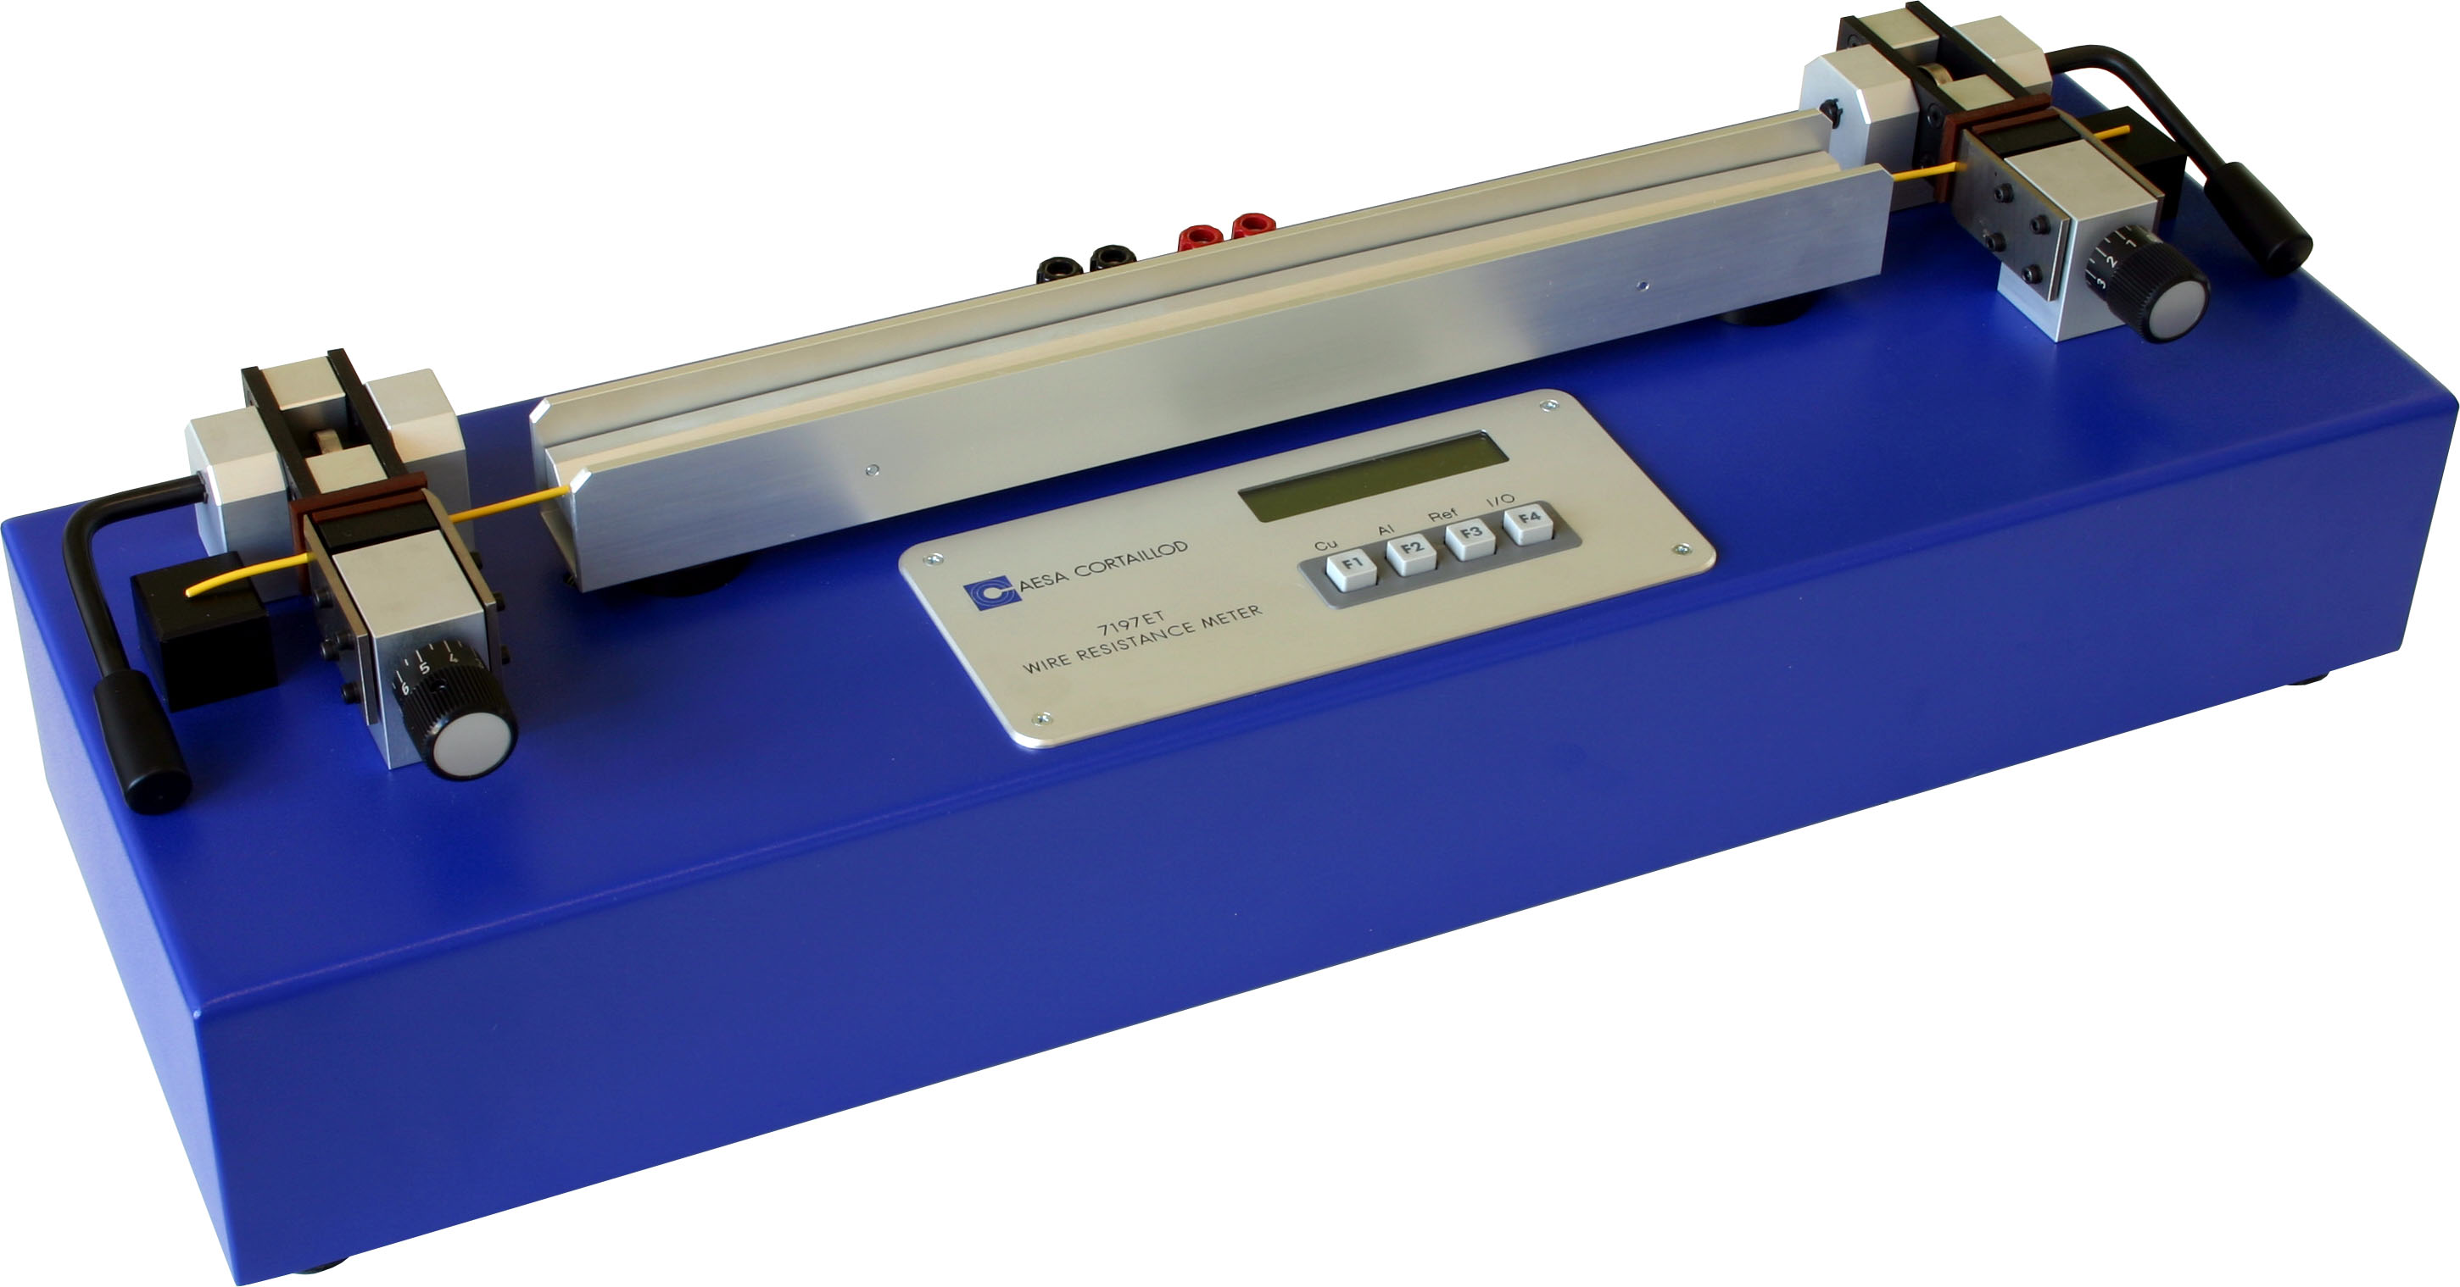
Different products are available:

The 7197ET unit covers small ranges
from dia. 0.15mm to dia. 6mm
7197ET

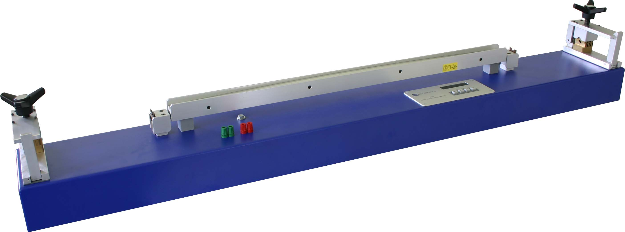
7195

The 7195 unit covers the range from dia. 0.15mm
to dia. 11mm (100mm²)

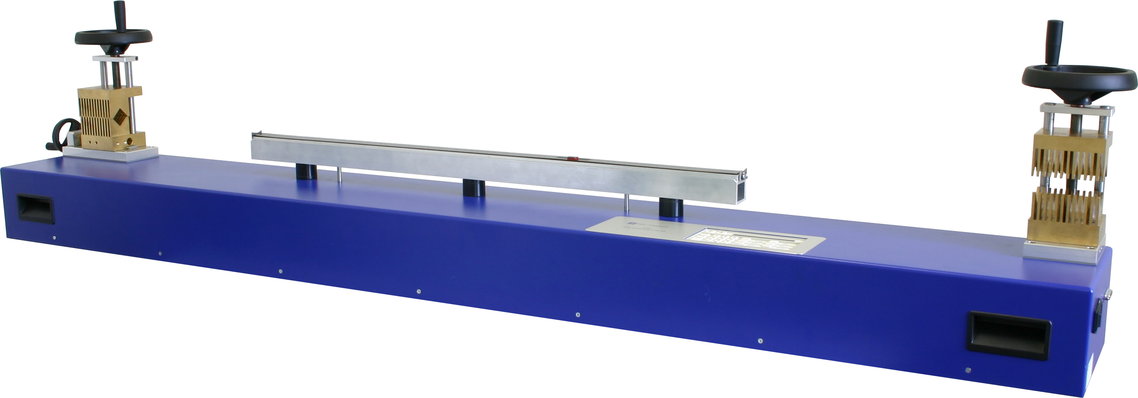
7198
The 7198 unit covers the range from dia. 0.4mm to dia. 25mm (500mm²)
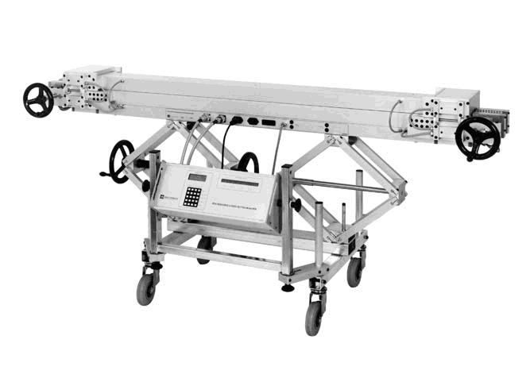

The 8130 family covers the range
from 2.5mm² to 2000mm²
8130

Please check our website www.aesa-cortaillod.com for the technical characteristics of the above solutions.

Our experience shows that savings are possible in the range of 0.3% to 2% for conductors from 1mm² to 240mm². Potential savings can reach 3% or more on large strands above 240mm².

Calculate your payback time for an AESA resistance bridge depending on the amount of raw material you buy every month and the expected percentage of material you think you can save.



